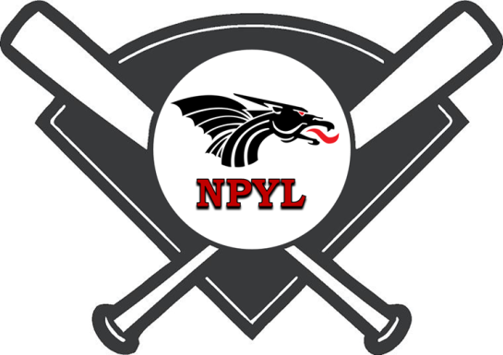
NPYL All-Star
Softball Shootout
Tournament Entry Form
July 5th – 8th, 2018

League name: ___________________________________________________________

Address: _______________________________________________________________

City: ____________________________ State: ____________ Zip: _______________

Contact: ___________________________ Home Phone: _______________________

Email: _______________________________ Cell Phone: _______________________

Please enter the following teams into the NPYL 2018 Tournament.
Complete Items Below:
Number of Teams Per Age Group  2 Maximum | Age Group | Entry Fee | Total Enclosed
 | 8U  7 and 8 Year Olds | $375  Register by June 5th $325
 | 10U  9 and 10 Year Olds | $375  Register by June 5th $325
 | 12U  11 and 12 Year Olds | $375  Register by June 5th $325
 | 14U  13 and 14 Year Olds | $375  Register by June 5th $325
 |  |  | Total $
- Please make all checks payable to NPYL
- Tournament Entries are due no later than July 1st
- Contact: Jon Thrasher jonthrasher@npyl.com
Greg Cain gregcain@npyl.com
- Mail all entries to: New Palestine Youth League
P.O. Box 202
New Palestine, IN 46163

