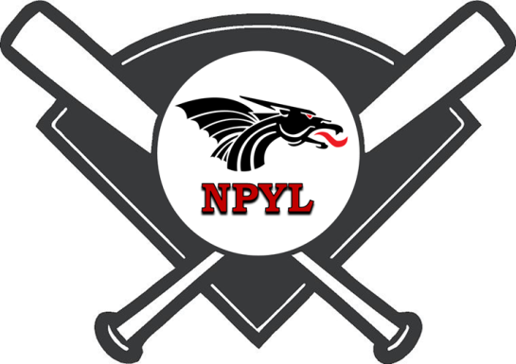
NPYL All-Star
Tournament Entry Form
July 12th – 15th, 2018

League name: ___________________________________________________________

Address: _______________________________________________________________

City: ____________________________ State: ____________ Zip: _______________

Contact: ___________________________ Home Phone: _______________________

Email: _______________________________ Cell Phone: _______________________

Please enter the following teams into the NPYL 2018 Tournament.
Complete Items Below:
Number of Teams Per Age Group  2 Maximum | Age Group | Entry Fee | Total Enclosed
 | 7U | $275
 | 9U | $300
 | 11U | $350
 |  |  | Total $
- Please make all checks payable to NPYL
- Tournament Entries are due no later than July 1st
- Contact: Jon Thrasher jonthrasher@npyl.com
Greg Cain gregcain@npyl.com
- Mail all entries to: New Palestine Youth League
P.O. Box 202
New Palestine, IN 46163

