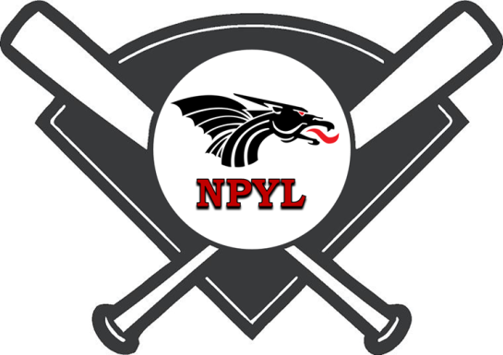
NPYL All-Star
Softball Shootout
Tournament Entry Form
July 7th – 11th, 2021

League name: ___________________________________________________________

Address: _______________________________________________________________

City: ____________________________ State: ____________ Zip: _______________

Contact: _____________________________________________________________

Phone: __________________________ Email: _______________________________

Number of Teams Per Age Group  2 Maximum | Age Group | Entry Fee | Total Enclosed
 | 8U  7 and 8 Year Olds | $375  Register by May 31st $325
 | 10U  9 and 10 Year Olds | $375  Register by May 31st $325
 | 12U  11 and 12 Year Olds | $375  Register by May 31st $325
 | 14U  13 and 14 Year Olds | $375  Register by May 31st $325
 |  | TOTAL | $
- Please make all checks payable to: NPYL
- Tournament Entries are due no later than June 29th. Late Entry Fee $400 per team.
- Contact: Bobby Wood at bobbywood@npyl.com 765-570-2359
- Mail all entries to: New Palestine Youth League
Attn: 2021 Shootout
P.O. Box 202
New Palestine, IN 46163

