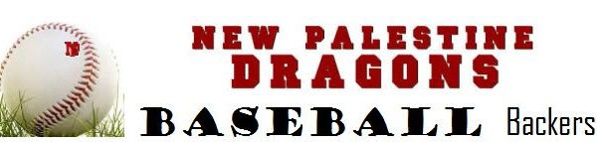

2019 Fall Baseball Camp
New Palestine High School Varsity Diamond
September 9, 16 & 23
6:30 pm – 8:15 pm
Camp is for players in 2nd – 8th grade and is for 3 consecutive Monday evenings.
Please arrive by 6:15 pm to check in and stretch before the clinic begins.

Participant: _______________________________________________________
Grade: ______________________ _________________________________
Parent: _______________________________________________________
Parent Email: _____________________________ Cell Phone:________________
Additional Participants: ___________________________________________________
Shirt size (please circle) Youth SM - Youth M – Youth L – Youth XL – Adult S – Adult M – Adult L

Please join Coach Lyons and his staff for the 10th Annual New Palestine Baseball Fall Camp. The coaches will be assisted by high school players and they will run the same drills as the high school team. These drills will consist of hitting, defensive footwork, proper throwing mechanics, pitching form, outfield play and base running. Participants will be divided into groups based on age. Please have your child wear baseball attire and bring their bat, glove, and drink.
Payment information

$50 (for all 3 dates) for NPYL participants by Aug 31 - $60 if registered after Sep. 1
$55 (for all 3 dates) if registered by August 31 - $65 if registered after Sep. 1

Online registration - https://newpalestinebaseballbackers.sportngin.com/register/form/745174212

Please mail your registration to: Jerome Davis
3685 N Hearthstone court
New Palestine, IN 46163

For more details – please email Jerome at:1jeromedavis@comcast.net

For weather updates, please follow Coach Lyons on Twitter @coachlyons22or New Palestine Baseball Backers on Facebook.

